CCF Admission Health Screening Form

Today’s Date: _______________ Time: _________ am/pm Admission date: _____________

Name:____________________________________________ ID #: __________________________________

D.O.B._________ Age: ______ Sex: F____ M_____ Race: _________ Bldg./Dorm/Unit:_____________

Blood Pressure: ______/______ Temperature: ________ Pulse: _________ Respirations: ___________

Allergies (drugs): ____________________________________ Type of reaction: _____________________
Food Allergies: _____________________________________ Type of reaction: _____________________
Environmental Allergies (cedar, mold, pollen, etc.): ________ Type of reaction: _____________________

Current Weight: _________lbs. Height: ______ft. _______ in.
Recent unplanned weight loss: Yes ____ No ____ Recent unplanned weight gain: Yes ____ No ____
If the answer is yes how much weight in what length of time? _____________________________________

TB skin test to be administered and read within 7 calendar days prior to admission or after admission to facility:

Current TB skin test:
Date given: __________ Date read: _________ Results: _______ mm.

If past history of previous positive TB skin test, give date ___________ and results ________________

TB Symptoms Screening Questionnaire Completed: Yes ___ No____ N/A ____ Date: ___________
Symptomatic: Yes ____ No ____ if yes, referred for medical evaluation: ________________________

Chest x-ray results (only if applicable): Date: _________ Results: ______________________________
Recommendations: _______________________________________________________________________

Medication History
List prescription drugs and over-the counter drugs currently being taken including
herbal preparations, vitamins and other supplements
Name of Medication Dosage Frequency/Instructions Reason for Medication Last Time Taken
Family Medical History
Does anyone in your family have a history of any of the following?
Health Problem | Yes | No | Who (mother, father, grandparent or sibling) | Health Problem | Yes | No | Who (mother, father, grandparent or sibling)
Alcoholism |  |  |  | Epilepsy / Seizures
Arthritis |  |  |  | High Blood Pressure
Cancer |  |  |  | Kidney Disease
Bleeding Disorder |  |  |  | Mental Illness
Diabetes |  |  |  | Mental Retardation
Drug Addiction |  |  |  | Stroke
Heart Disease |  |  |  | Thyroid Disease

Past Medical History: (accident, injury, major hospitalizations, surgery): __________________________
_________________________________________________________________________________________
__________________________________________________________________________________________
__________________________________________________________________________________________

Last tetanus immunization: _____________ Recent fall, head injury or surgery: ____________________

Do you now have or have you ever been told that you have any of the following problems?
 | Yes | No | Swelling of | Yes | No |  | Yes | No |  | Yes |  | No
Alcoholism |  |  | Ankles/Legs |  |  | Syphilis |  |  | Drug abuse
Allergies |  |  | Gout |  |  | Gonorrhea |  |  | Seizures
Anemia |  |  | Cancer |  |  | Herpes |  |  | Stroke
Asthma |  |  | Diabetes |  |  |  |  |  | Slurred Speech
Bronchitis |  |  | Thyroid disease |  |  | Other STD’s |  |  | Numbness
Chronic Cough |  |  | Kidney disease |  |  | Broken bones |  |  | Paralysis
Frequent colds |  |  | Gallbladder |  |  | Back problems |  |  | Dizziness
Hay fever |  |  | Heartburn |  |  | Dentures |  |  | Fainting
Shortness of breath |  |  | Gastrointestinal Ulcers |  |  | Hearing loss  Left / Right Ear |  |  | Headaches  Frequent / Severe
Sinusitis |  |  | Nausea |  |  | Hearing Aid |  |  | Males Only
Emphysema |  |  | Vomiting |  |  | Eye glasses |  |  | Prostate problem
Tuberculosis |  |  | Sickle Cell |  |  | Contact Lens
Pneumonia |  |  | Hepatitis |  |  | Glaucoma |  |  | Females Only
Wheezing |  |  | Arthritis |  |  | Cataracts |  |  | Pregnant
Coughing up Blood |  |  | High  Cholesterol |  |  | High Blood Pressure |  |  | Last Menstrual  Cycle | Date
Chest pain |  |  | Hernia |  |  | Hemorrhoids |  |  | Missing periods
Heart disease |  |  | Varicose veins |  |  | Constipation |  |  | Last Pap Smear
Heart Murmur |  |  | Leg Cramps |  |  | Diarrhea |  |  | Last Breast Exam
Pace Maker |  |  | Vascular disease |  |  | Blood in stool |  |  | Postmenopausal
If you answered yes to any of the questions above, please explain: _________________________________ ____________________________________________________________________________________________________________________________________________________________________________________

Are there any other health problems not included in the list above?________________________________ __________________________________________________________________________________________
__________________________________________________________________________________________
Family physician’s information if applicable: __________________________________________________
__________________________________________________________________________________________
__________________________________________________________________________________________

Dental Problems: (any current dental problems that require immediate attention):________________________
__________________________________________________________________________________________
__________________________________________________________________________________________

Mental illness current or past history: (any past history of suicide attempts or ideation)__________________
Are you currently having any thoughts of harming yourself or others? _________________________________
Have you ever received treatment for mental illness? Yes____ No____ When? _________ Where? _________
Have you ever been diagnosed with any of the following, please circle one or all that apply:
Depression Schizophrenia Compulsive disorder Attention deficit disorder Others________
Anxiety disorder Bipolar disorder Eating disorder Hyperactivity Disorder _____________
Panic attacks Sleep disorders Memory Loss Mental Retardation None: ________
Are you currently receiving mental health services? _______ Last doctor’s visit: _________________________
Attending Psychiatrist: _______________________________ Telephone #: ___________________________
__________________________________________________________________________________________

Do you smoke or use other tobacco products? Yes___ No ___ If the answer is yes, what type? _________
Length of time smoking/using: ____________________ Amount used daily __________________________
Have you ever attempted to stop smoking or using tobacco products? Yes ____ No ____ When ________
Comments: _______________________________________________________________________________

Alcohol and Drug Use/Abuse History: Inquire about the use of various types of alcohol (beer, wine, liquor), illicit drugs, inhalants, prescription drugs, over-the counter drugs of abuse, and any other drugs not mentioned.
Mode of Use Problems after
Types of alcohol and drugs used: (IV, smoke, oral, etc) Amounts Used Frequency of Use stopping use Last date used

General Observations:

- Behavior which includes state of consciousness, mental status, appearance, conduct, tremors and sweating.
__________________________________________________________________________________________
____________________________________________________________________________________________________________________________________________________________________________________

- Body deformities, ease of movement, limited range of motion, assistive devices required: _______________
__________________________________________________________________________________________
__________________________________________________________________________________________
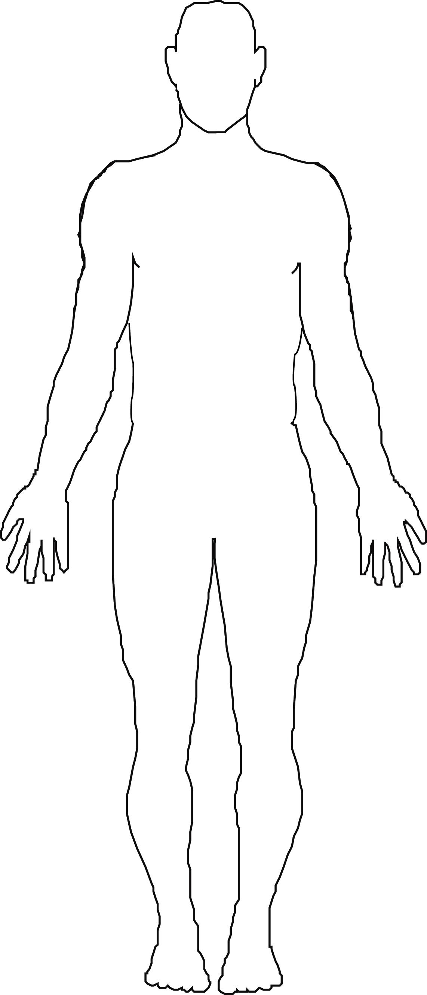
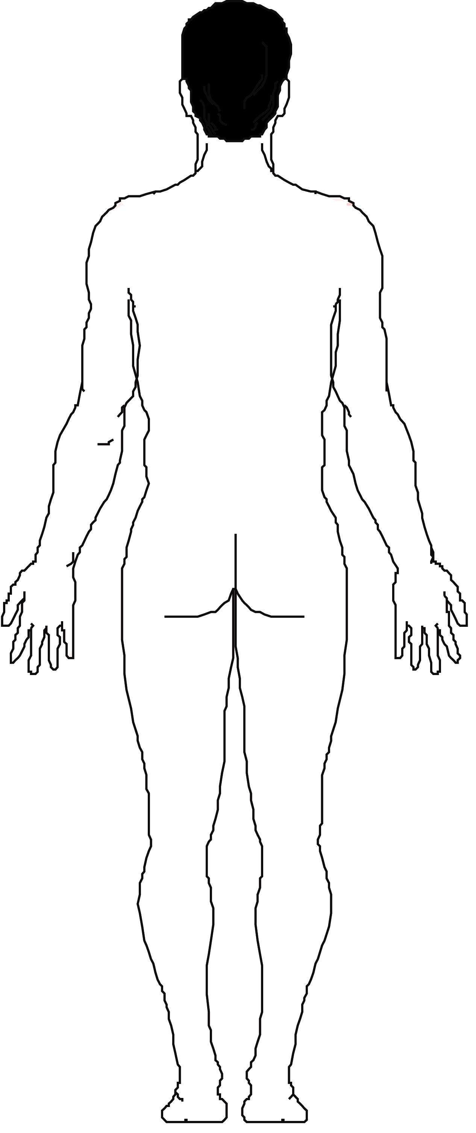
3. Condition of skin, including trauma markings, bruises, lesions, open sores, jaundice (yellow), skin rashes, infestations of the skin (lice, scabies, etc..) and needle marks or tracks or other indication of drug abuse: _____________________ ______________________________________________________
____________________________________________________________________________________________________________
______________________________________________________

4. Special skin markings (Tattoos, body piercing, etc.) _________ ______________________________________________________
____________________________________________________________________________________________________________
______________________________________________________

Codes for Body Outline: A - abrasion, B -bruises, C - cut, L - laceration, P - piercing, R - rash, T- tattoo
S - scar, N - needle marks/ tracks, BR - burn, O - open sore, ST – stitches.
__________________________________________________________________________________________

Regular Diet: Yes _____ No _______ Special Dietary Needs: _______________________
__________________________________________

Activity Level: Total______ Limited _______ Lower bed bunk required: Yes _____ No _____
Physical restrictions: _______________________ Cleared for Kitchen Duty: Yes _____ No _____
_________________________________________

Recommendations: ________________________________________________________________________ ____________________________________________________________________________________________________________________________________________________________________________________

_________________________________________ _____________________________________ _______________
Printed Name and Title Signature and Title Date
(Physician, PA, NP, RN, LVN, EMT-P) (Physician, PA, NP, RN, LVN, EMT-P)

I verify that the information that I have provided regarding my past medical history and current medical problems are correct to the best of my knowledge, and I authorize this information to be released to the residential facility.

__________________________________ _______________________________ ____________
Resident’s Printed Name Resident’s Signature Date

